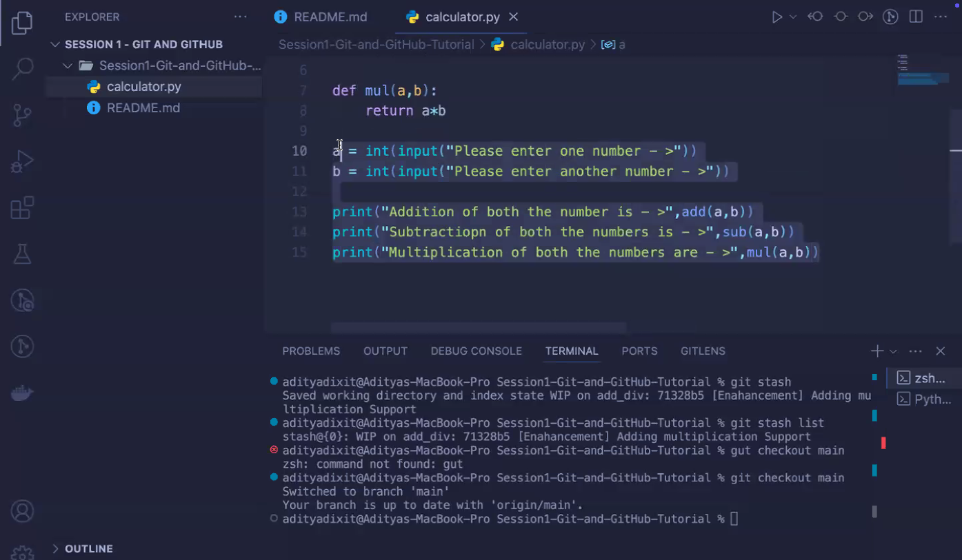

What is this? Whats main & branch whats stash and whats commit and adding a message etc checkout and push and merge and revert? (merge conflict arises)